Daniil Slesarenko

B00810091

23 July 2022

CSCI 4140

Assignment 2

Git Access

The project can be found at git via this link:

https://github.com/slesarenko-d/CSCI4140-A2

my git id is slesarenko-d

SQL statements

CREATE TABLE `client_091` (

`clientId_091` int NOT NULL,

`clientCity_091` varchar(45) DEFAULT NULL,

`dollarsOnOrder_091` int DEFAULT NULL,

`clientStatus_091` varchar(45) DEFAULT NULL,

`clientName_091` varchar(45) DEFAULT NULL,

`clientCompPassword_091` varchar(45) DEFAULT NULL,

`moneyOwed_091` int DEFAULT NULL,

PRIMARY KEY (`clientId_091`)

) ENGINE=InnoDB DEFAULT CHARSET=utf8mb4 COLLATE=utf8mb4_0900_ai_ci;

CREATE TABLE `line_091` (

`lineNum_091` int NOT NULL,

`poNum_091` int DEFAULT NULL,

`partNum_091` int DEFAULT NULL,

`partPrice_091` int DEFAULT NULL,

`partQuant_091` int DEFAULT NULL,

KEY (`lineNum_091`),

KEY `poNum_idx` (`poNum_091`),

KEY `partNum_091_idx` (`partNum_091`),

CONSTRAINT `partNum_091` FOREIGN KEY (`partNum_091`) REFERENCES `part_091` (`partNo_091`),

CONSTRAINT `poNum_091` FOREIGN KEY (`poNum_091`) REFERENCES `po_091` (`poNo_091`)

) ENGINE=InnoDB DEFAULT CHARSET=utf8mb4 COLLATE=utf8mb4_0900_ai_ci;

CREATE TABLE `part_091` (

`partNo_091` int NOT NULL,

`partDescription_091` varchar(45) DEFAULT NULL,

`QoH_091` int DEFAULT NULL,

`partName_091` varchar(45) DEFAULT NULL,

`currentPrice_091` int DEFAULT NULL,

PRIMARY KEY (`partNo_091`)

) ENGINE=InnoDB DEFAULT CHARSET=utf8mb4 COLLATE=utf8mb4_0900_ai_ci;

CREATE TABLE `po_091` (

`poNo_091` int NOT NULL,

`datePO` datetime DEFAULT NULL,

`status_091` varchar(45) DEFAULT NULL,

`clientID_091` int DEFAULT NULL,

PRIMARY KEY (`poNo_091`),

KEY `clientID_091_idx` (`clientID_091`),

CONSTRAINT `clientID_091` FOREIGN KEY (`clientID_091`) REFERENCES `client_091` (`clientId_091`)

) ENGINE=InnoDB DEFAULT CHARSET=utf8mb4 COLLATE=utf8mb4_0900_ai_ci;

(I added FK after I created the tables)

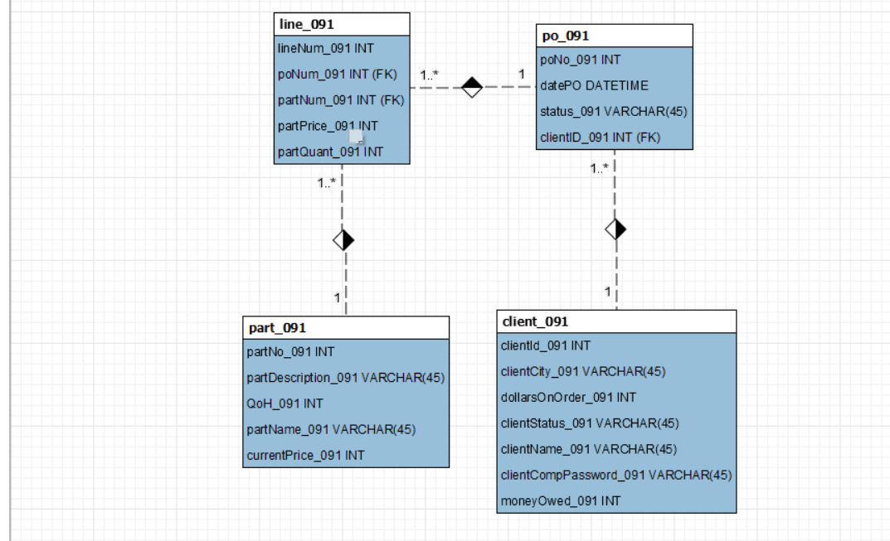

Screenshots

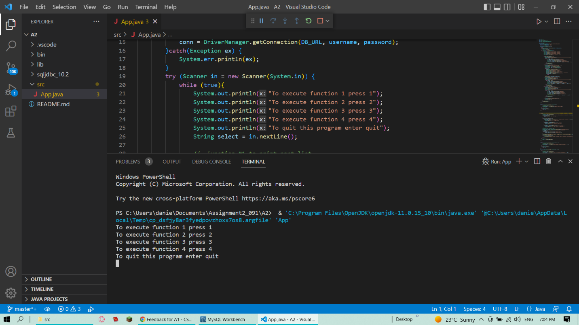

Function 1

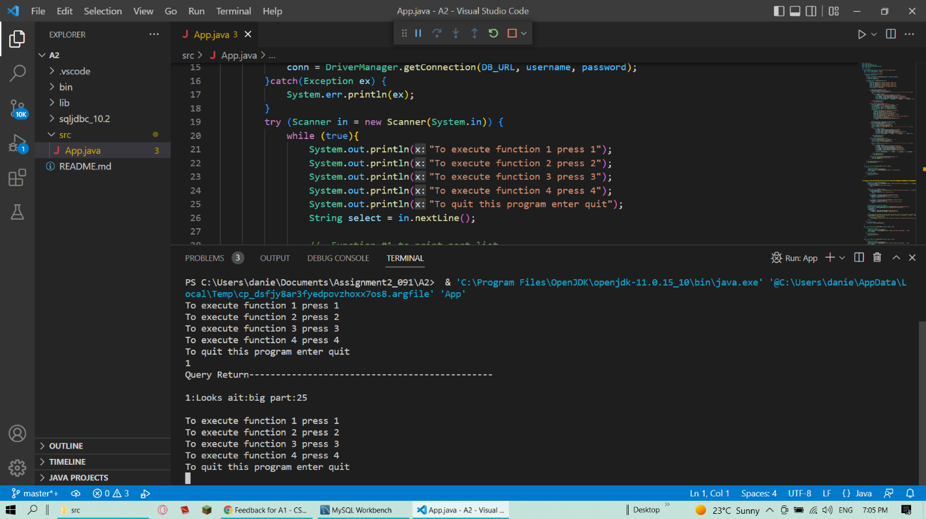

Function 3

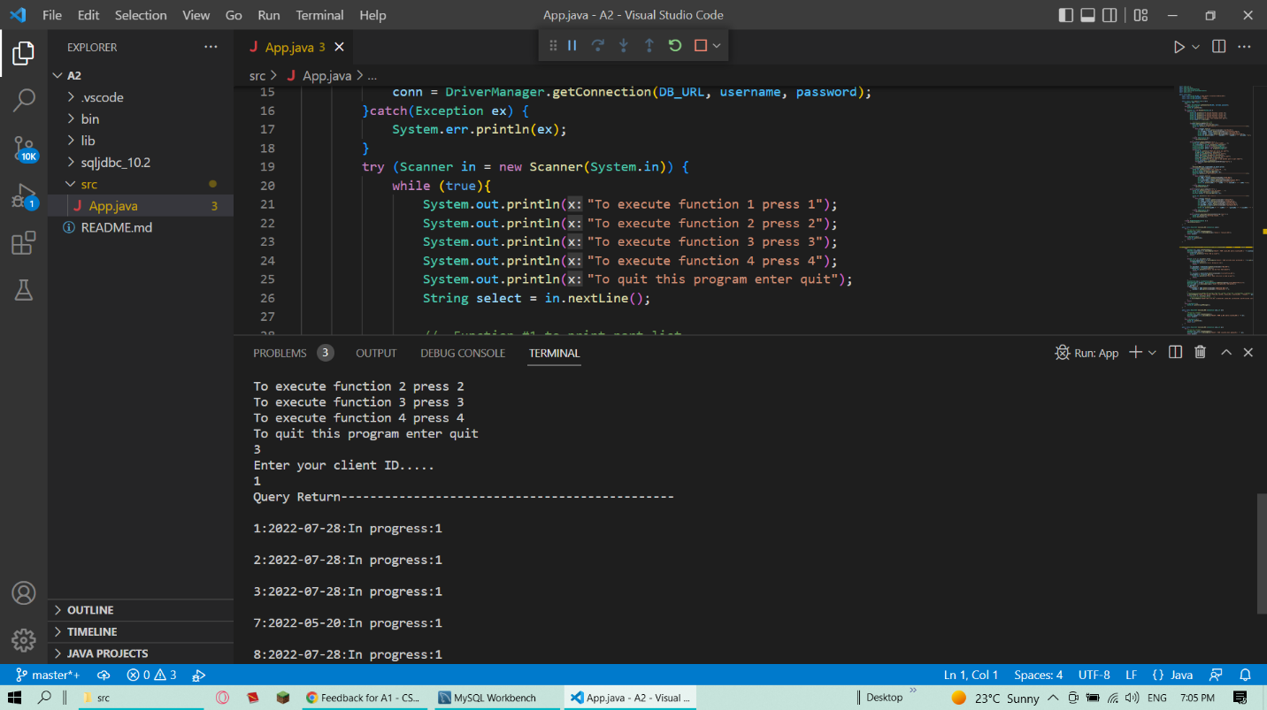

Function 4

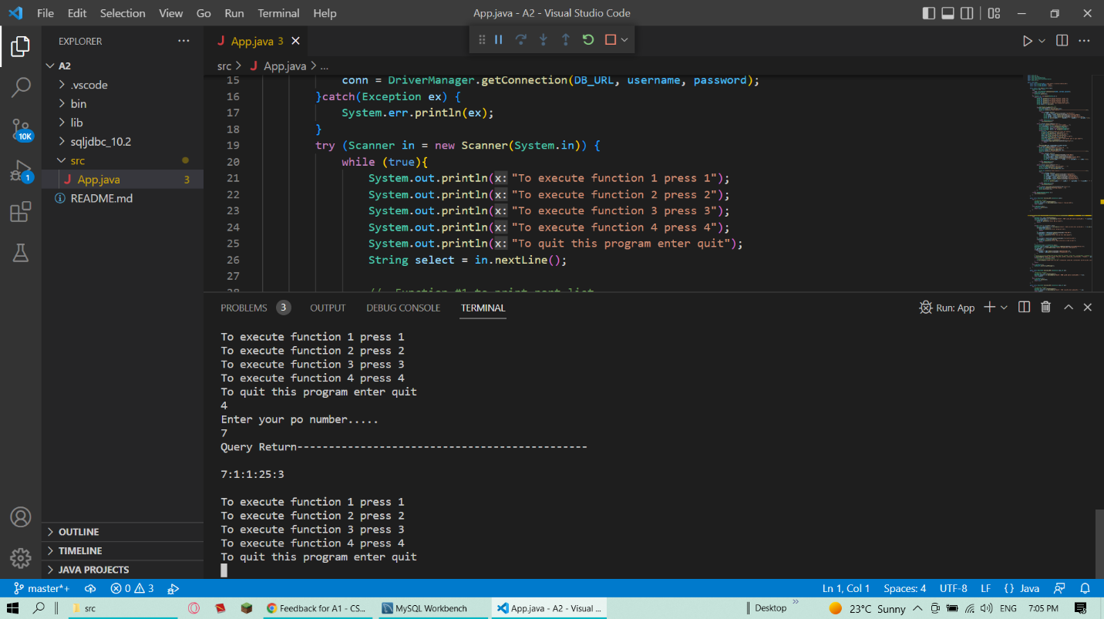

Input validation for function 2: wrong client

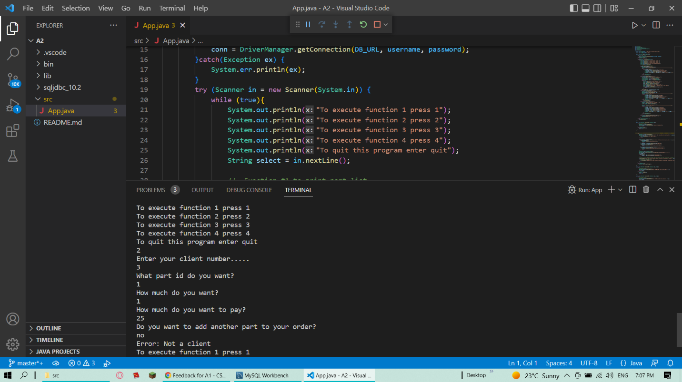

Input validation for function 2: wrong part id

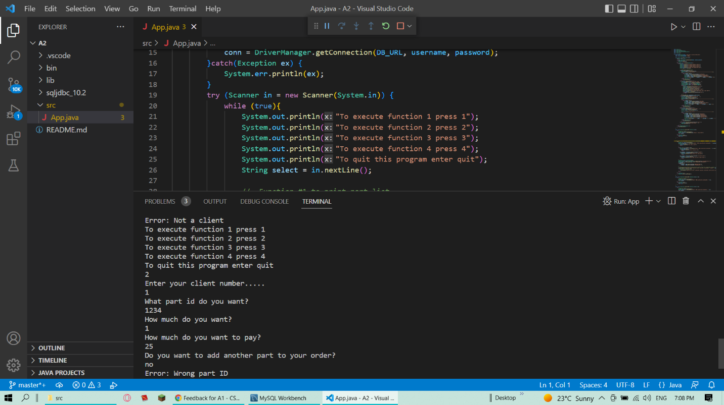

Input validation for function 2: wrong amount

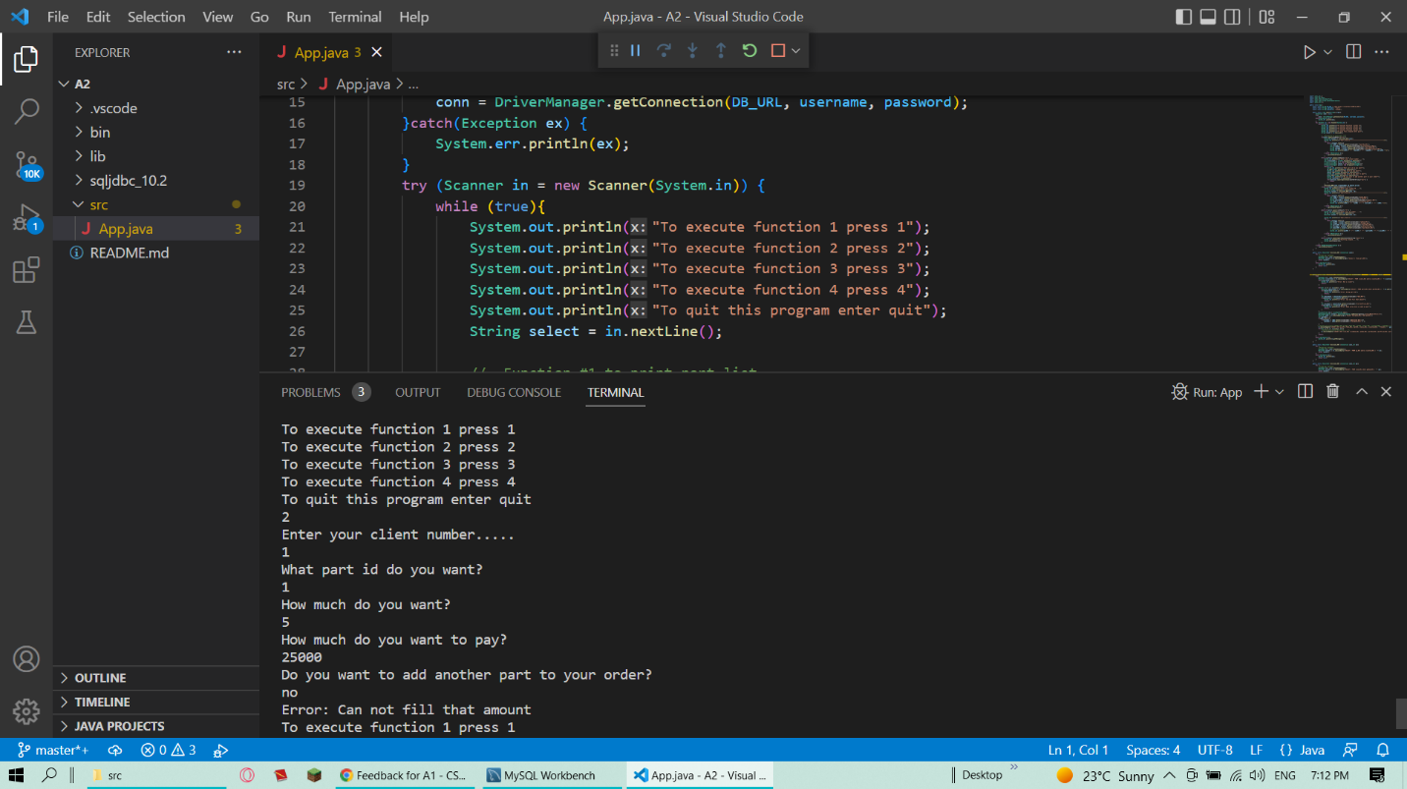

Input validation for function 2: wrong price

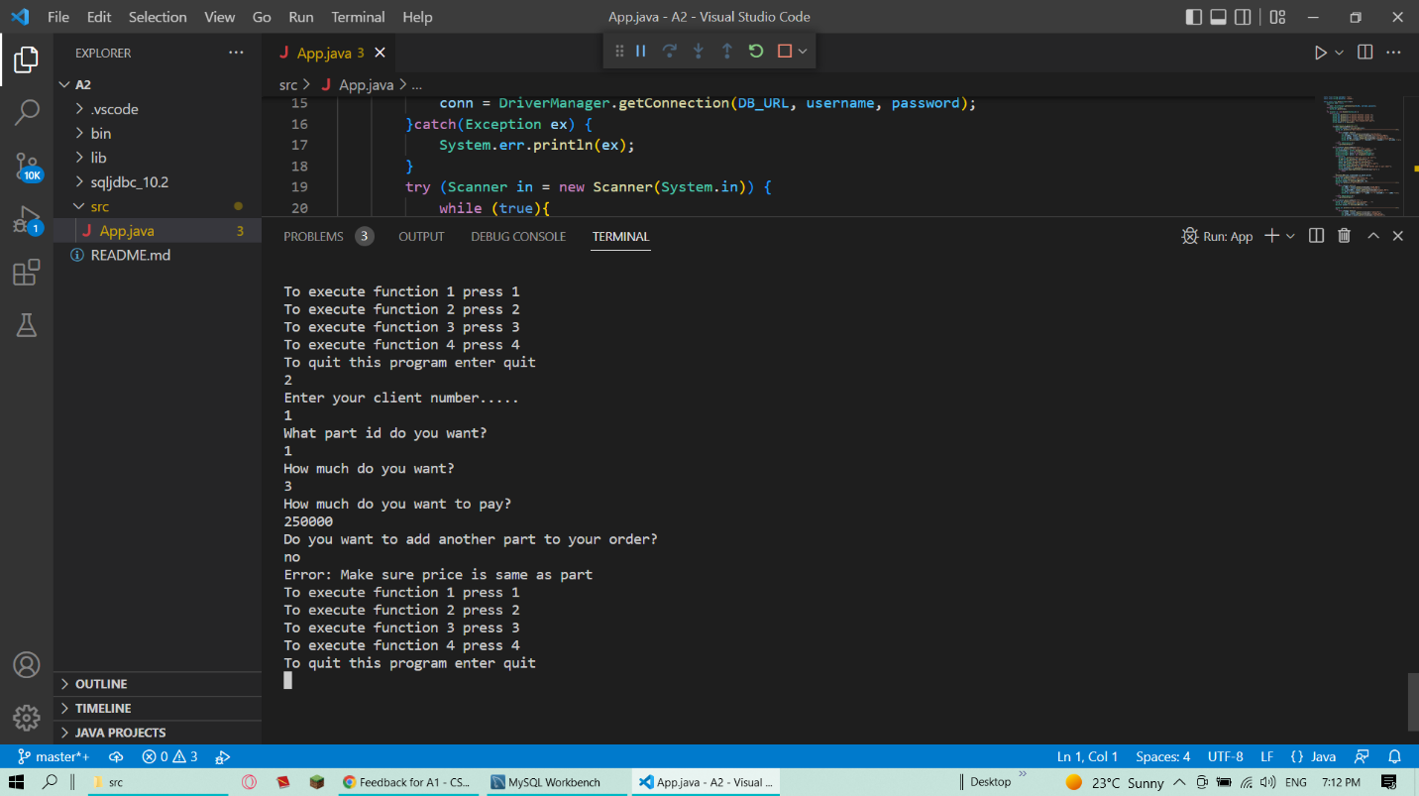

Function 2 working and updating the database

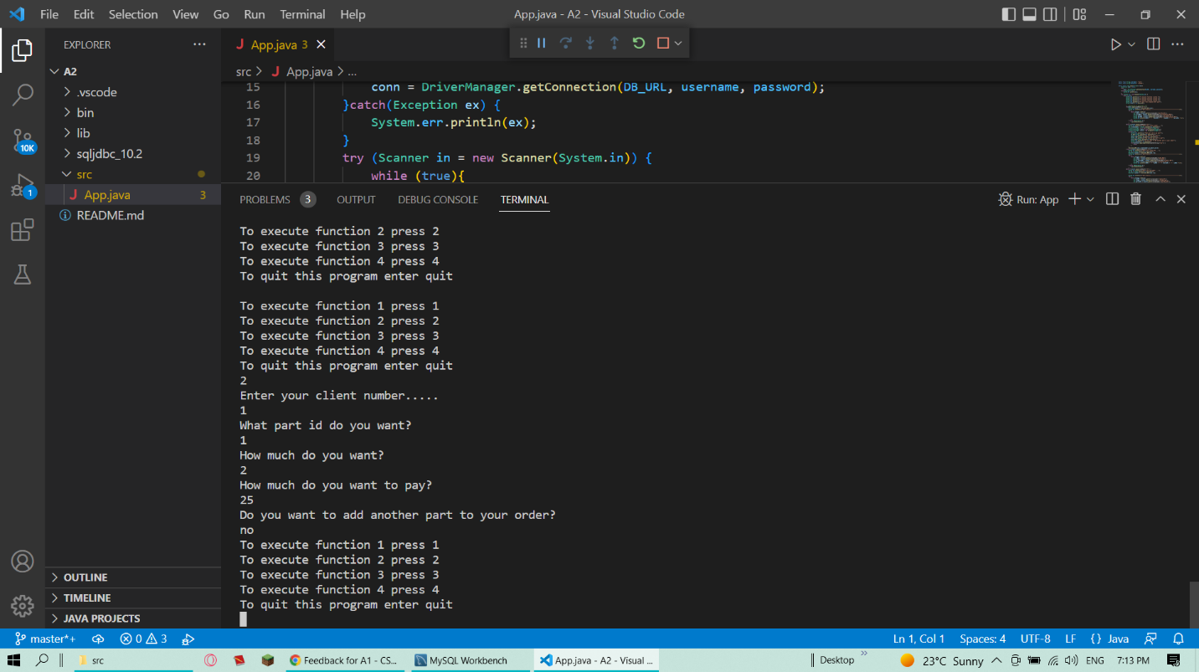

Before:

After: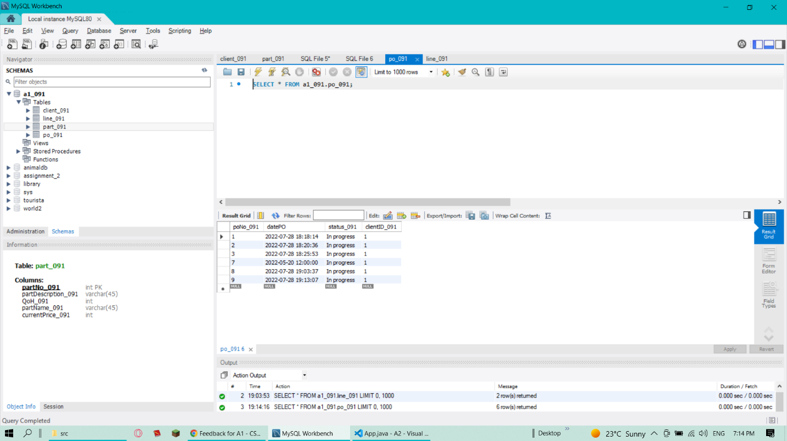

Before:

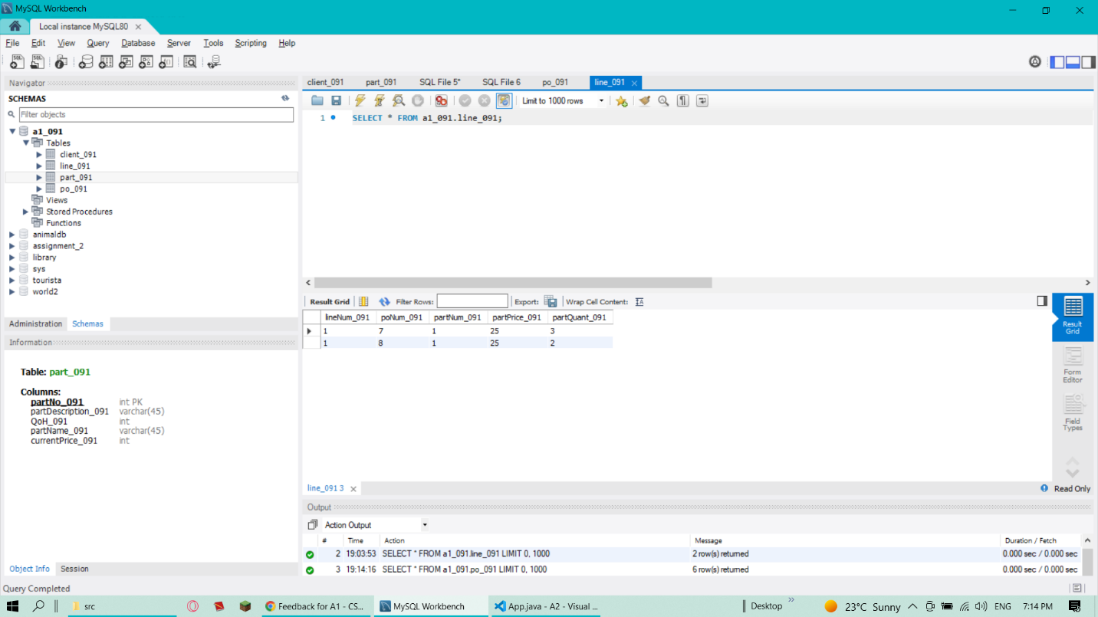

After

